Date : 01-Sep-2026 7a) Configuration of HyperV on Windows of VMs
Aim:
To configure Hyper-V on Windows for creating and managing virtual machines (VMs), enabling efficient virtualization and resource utilization.
Steps:
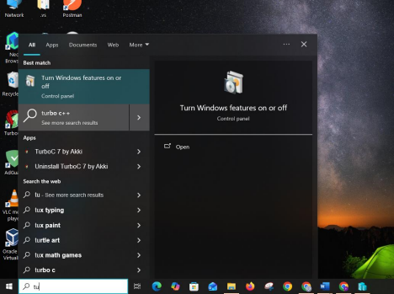
1) Click Turn Windows features on or off.

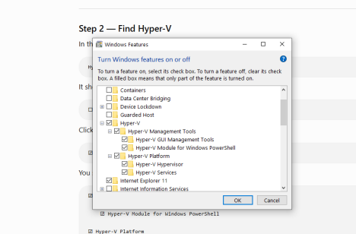
2) Find Hyper-V select all hyper -V and restart

3) After your PC restarts Press the Windows key and search: Hyper-V Manager
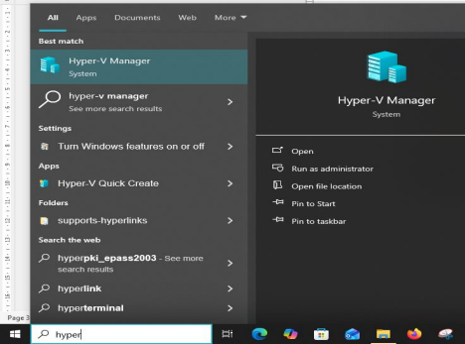
4) The hypervisor manager will open
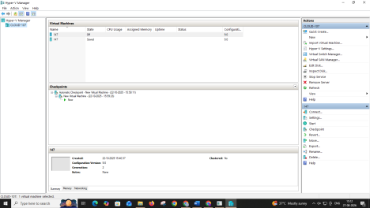

RESULT:
Thus the configuration Hyper-V on Windows for creating and managing virtual machines (VMs),
enabling efficient virtualization and resource utilization has been executed successfully.
Date:01-Sep-2026 7b) Creation of VM, Powershell commands, Management
Aim:
To create and manage Virtual Machines (VMs) using Hyper-V, including PowerShell commands for automation and efficient administration.
Procedure:
VM Installation without PowerShell
- Open Tools → Hyper-V Manager → Right-click on the server and select New → Virtual Machine.
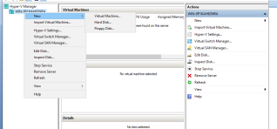
- Specify the Name and Location of the VM, then click Next.
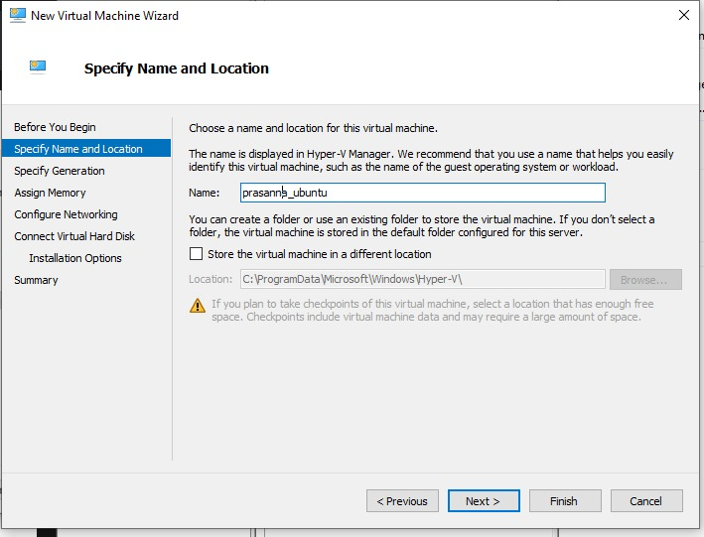
- Select Generation 2 and click Next.
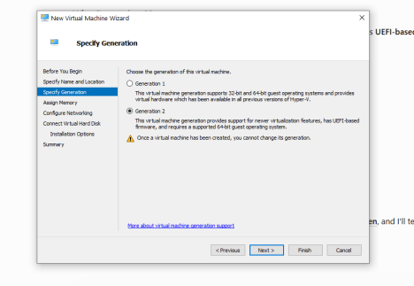
- Assign the memory for the VM (for safety, allocate 2 GB) and click Next.
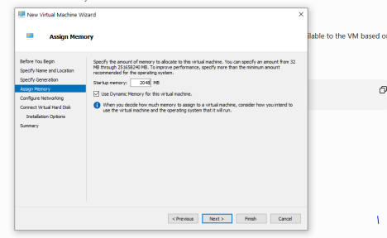
- Configure the network by selecting Default Switch, then click Next.
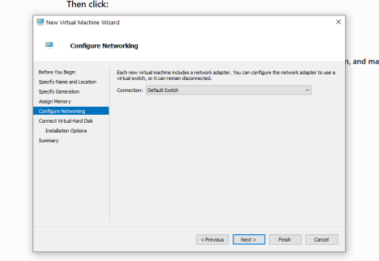
- Create or connect the Virtual Hard Disk, then click Next.
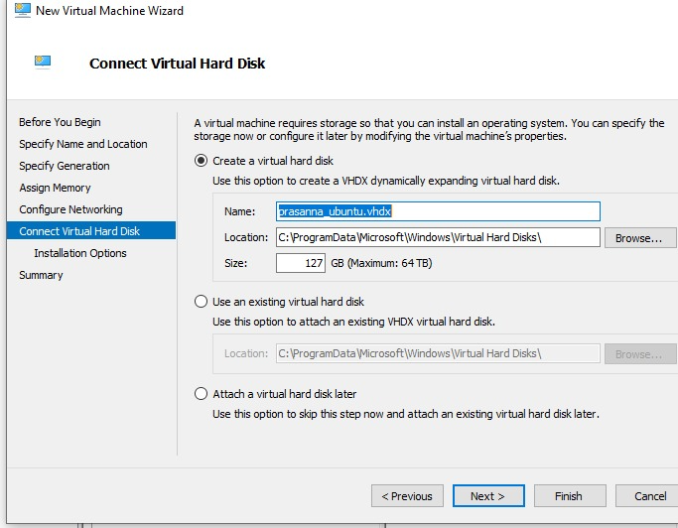
- Select Install an operating system from a bootable image file and import the required ISO file (Ubuntu), then click Next.
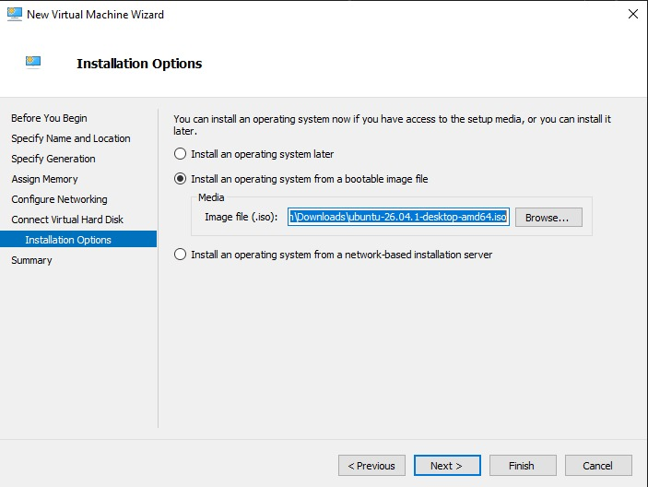
- Click Finish to create the virtual machine.
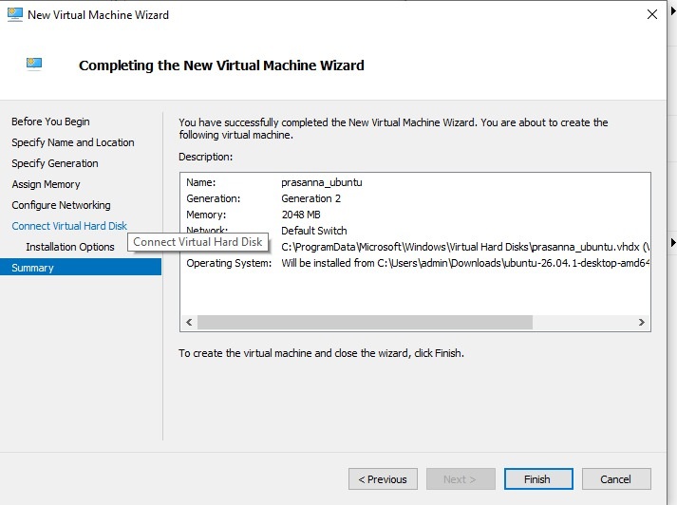
- Open the Settings of the VM and change the Security Template to Microsoft UEFI Certificate Authority.
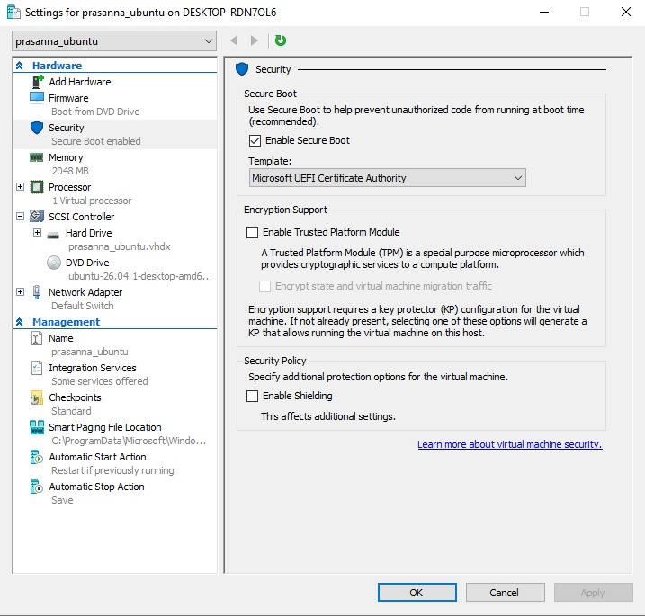
- Start the VM from Hyper-V Manager by selecting Connect and then Start.
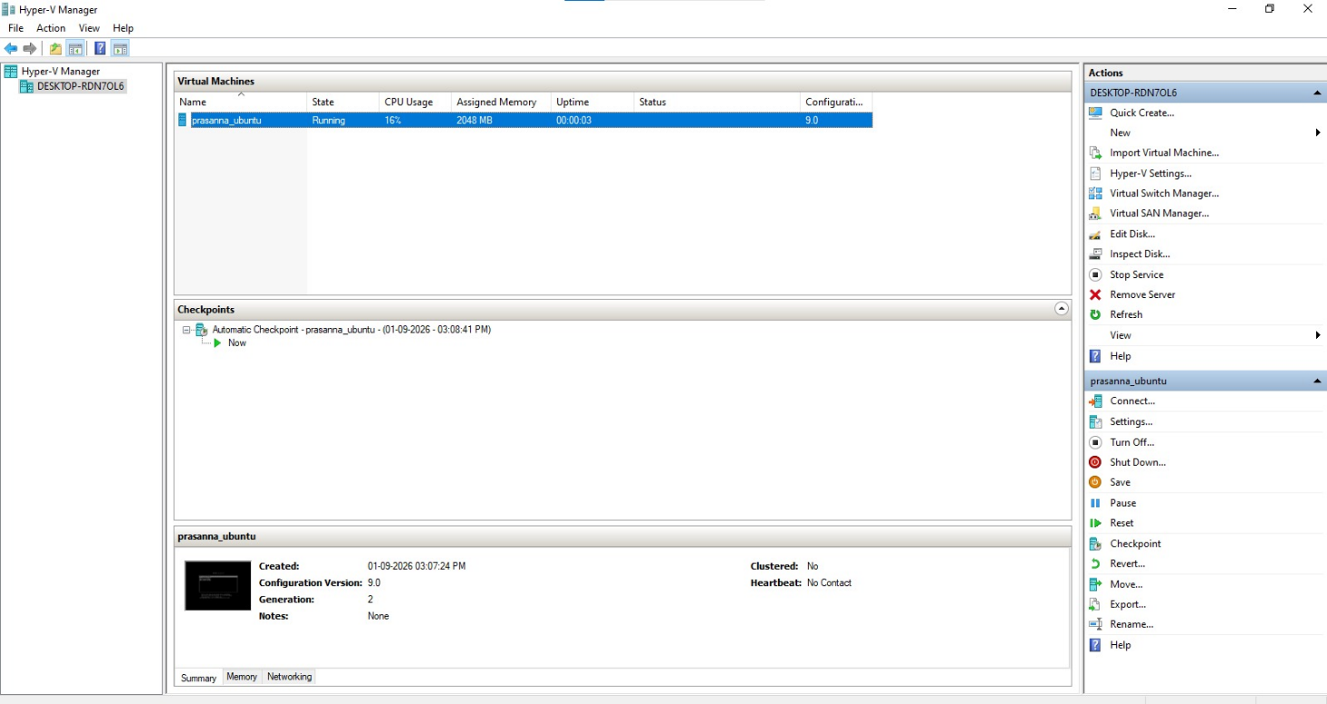
- The Ubuntu installation setup will appear. Follow the installation steps shown in the screenshots.
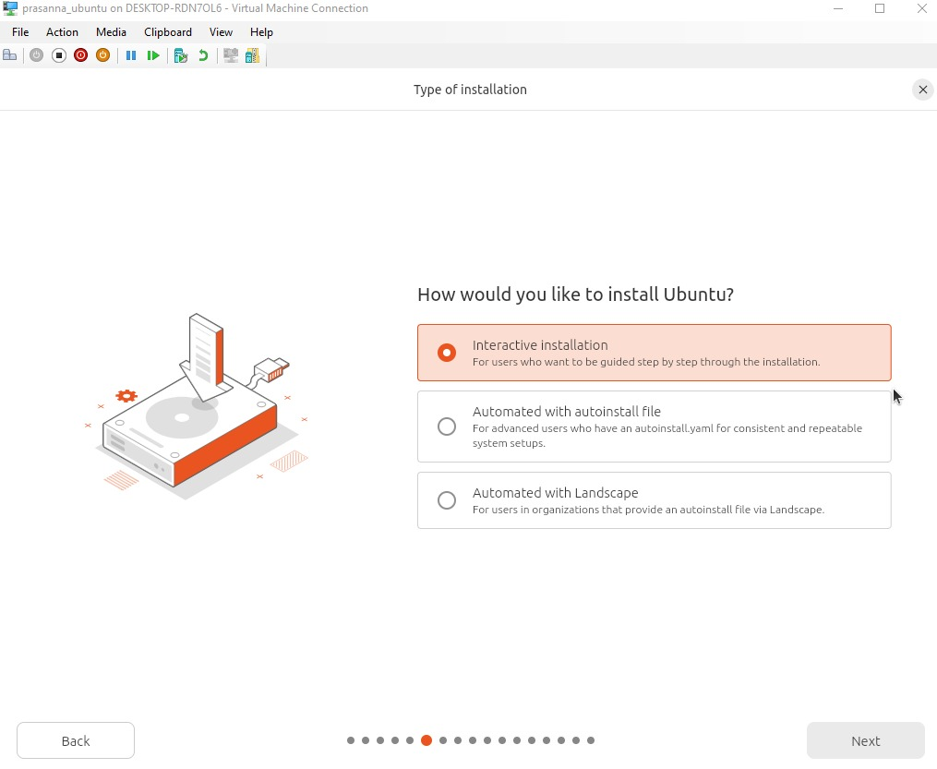
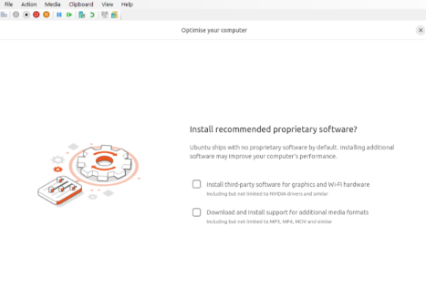
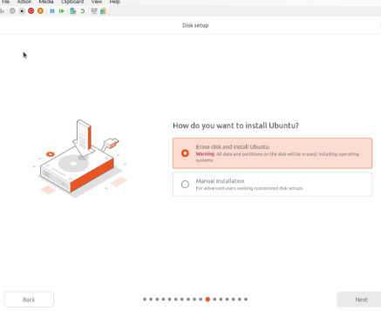

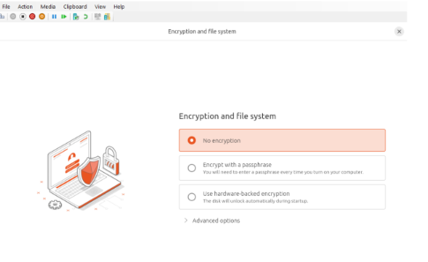
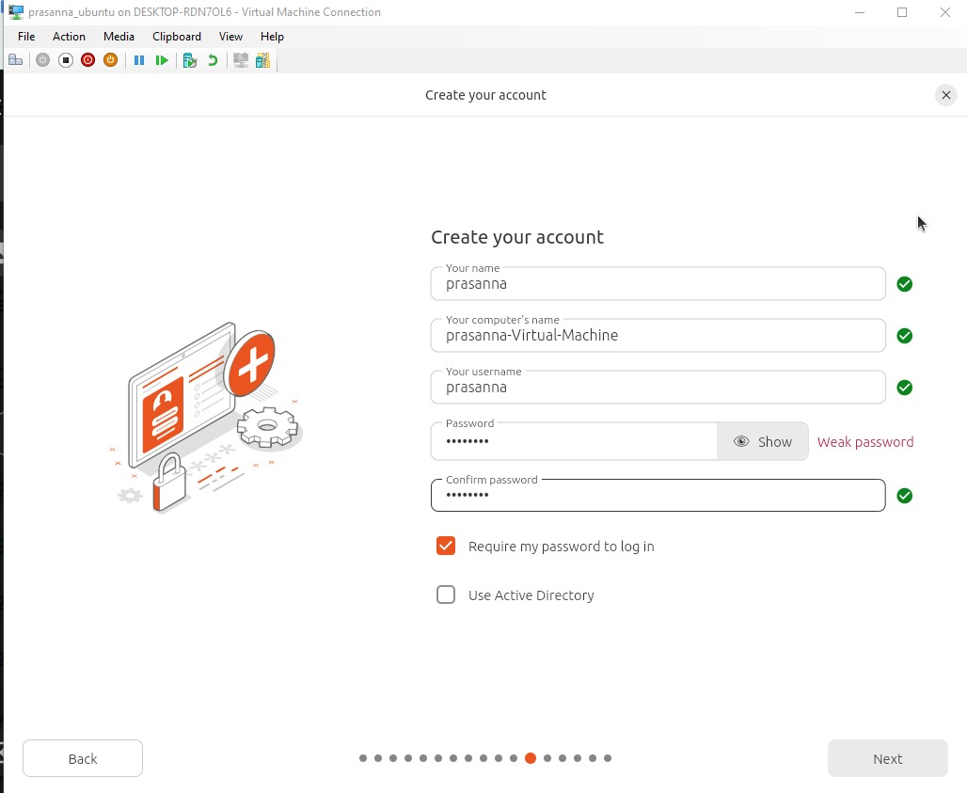
After the installation is completed, restart the VM. The Ubuntu desktop will appear successfully.
VM Installation using PowerShell
Procedure:
- Display the available virtual switches.
Get-VMSwitch
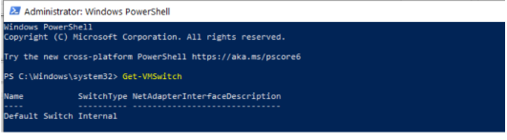
- Create a new virtual machine with a virtual hard disk.
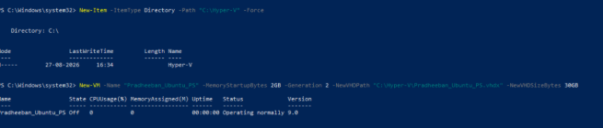
- Assign the virtual switch obtained from the Get-VMSwitch command.

- Attach the Ubuntu ISO file to the virtual DVD drive.
- Start the virtual machine.

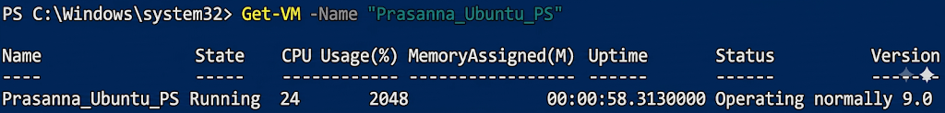
- Check the status of the virtual machine.

- Open Hyper-V Manager, locate the created VM, click Connect, and proceed with the Ubuntu installation.

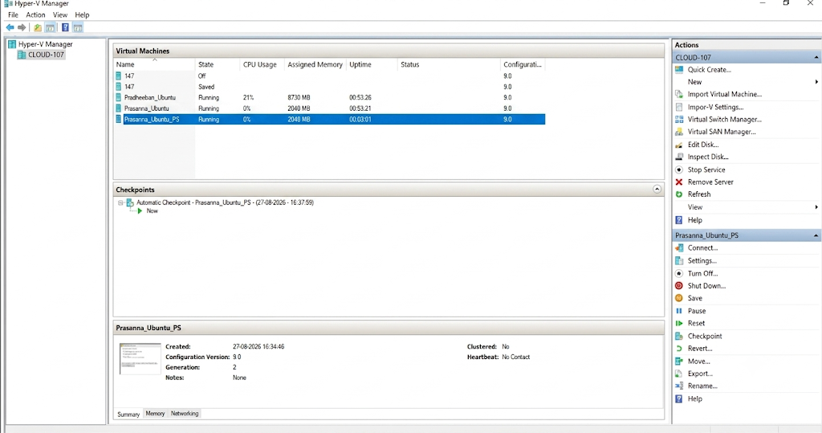
PowerShell Commands
1. To view the status of all virtual machines
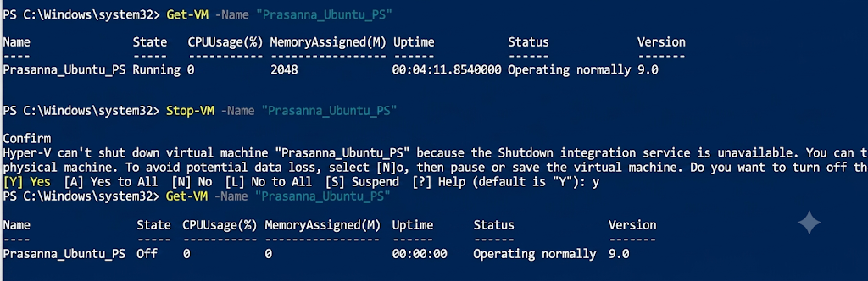

2. To stop a virtual machine

Migration
Right-click the virtual machine in Hyper-V Manager. And Select Move.
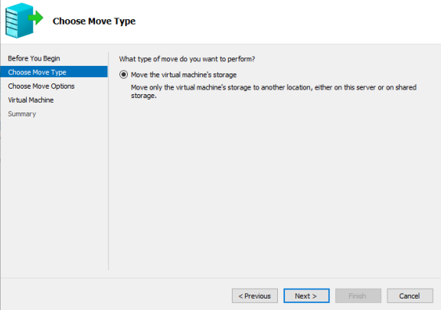
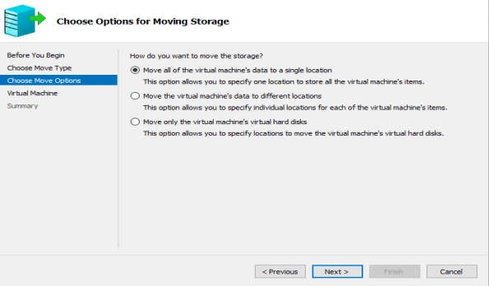
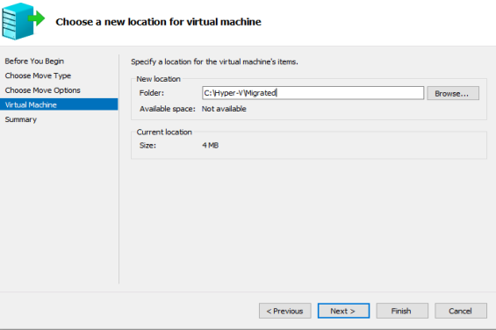
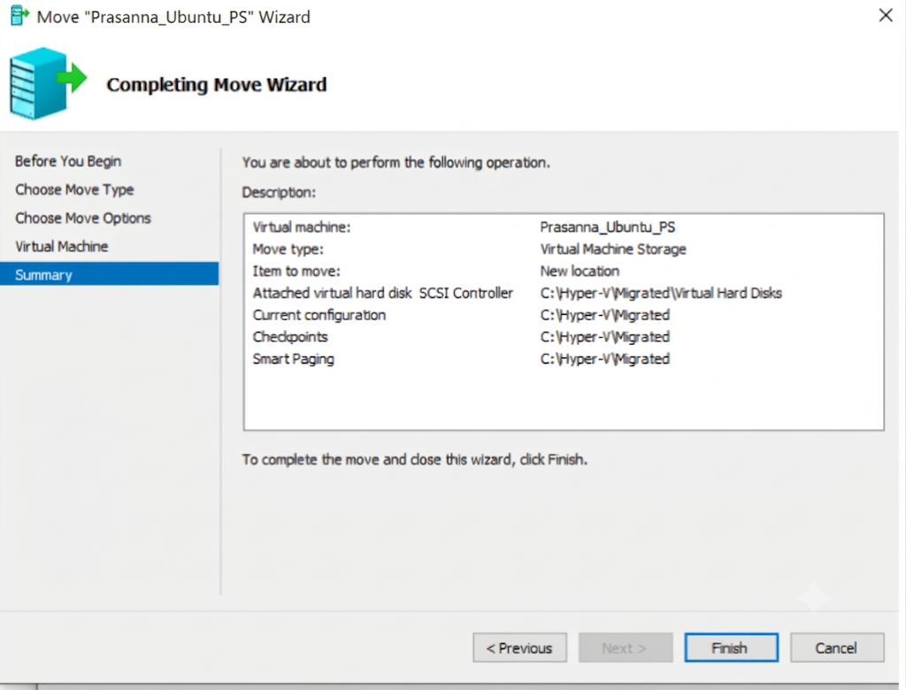

The VM is successfully moved.
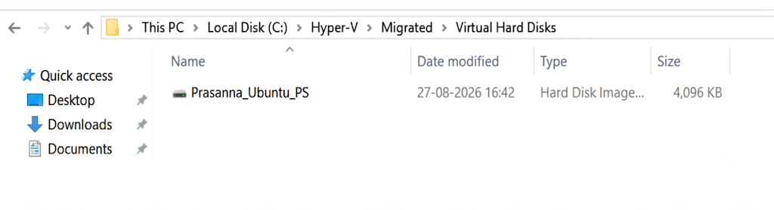

Result:
Thus, the creation and management of Virtual Machines (VMs) using Hyper-V, including PowerShell commands for automation and efficient administration, has been executed successfully.

